Lab Objective: In this lab, students will define basic programming concepts, create coding segments based on specific scenarios, and debug programs using Visual Studio 2015.
Resources required:
Hardware: Xendesktop
Software: Visual Studio 2015
Part 1:
Instructions
Please provide short answer explanations to the questions down below. Include C syntax were noted.
- Describe how a counter controlled iteration structure works. Include each syntax item that is required to execute this structure successfully. Provide a C for() statement syntax example with your response.
- Explain the difference between a for() and a switch statement. Provide real world examples of when you would use each.
- Explain why we would use a function in a C program. What are the three items that are needed to implement this structure correctly?
- With functions we can pass arguments by value or by reference. Please describe the difference.
- What is a recursive function? How does recursion relate to iteration?
Part 2: Instructions
Open your Visual Studio 2015 XenDesktop image, create a new project, and type the coding segments down below into the compiler. Run the program(s) (Debug > Start without debugging).
- Execute the following code and identify the errors in the program. Debug the program and provide the correct version of the code.
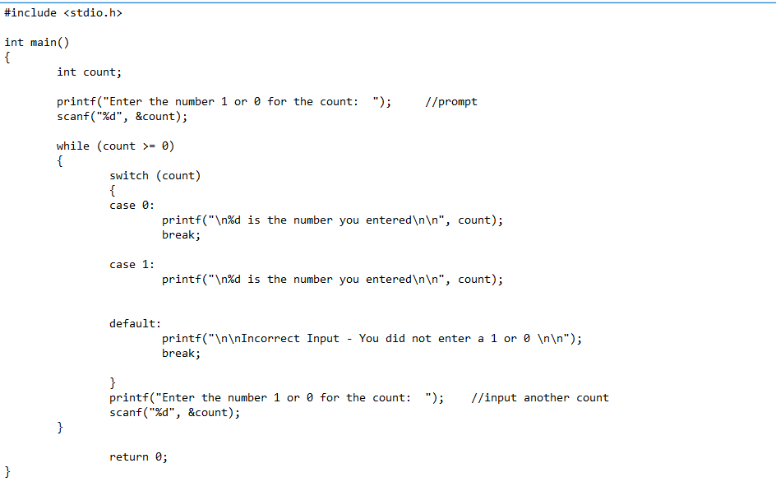
- Execute the following code and identify the errors in the program. Debug the program and provide the correct version of the code. Note: Be sure to check the output screen to see if the correct values are displaying according to the output statements.
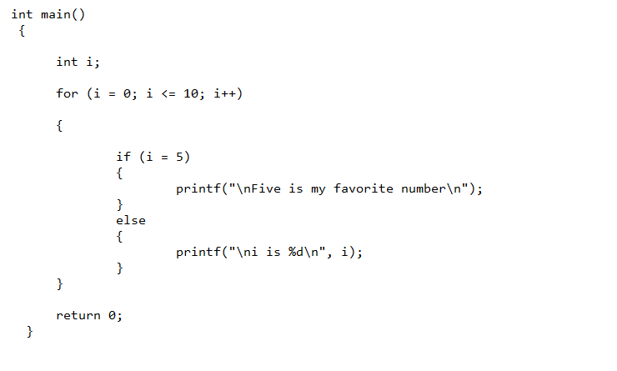
- Execute the following code and identify the errors in the program. Debug the program and provide the correct version of the code.
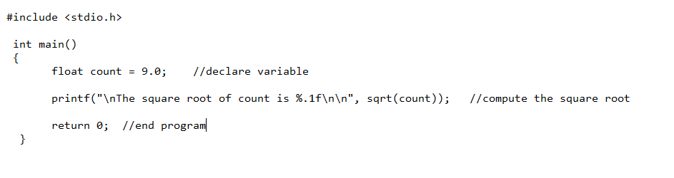
- Execute the following code and identify the errors in the program. Debug the program and provide the correct version of the code.
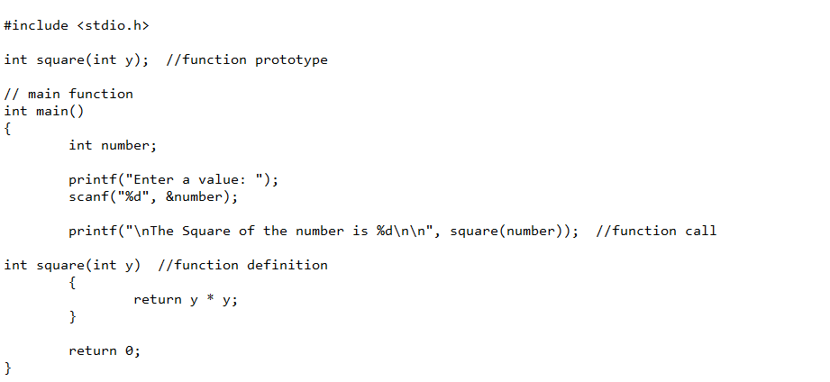
- Execute the following code and identify the errors in the program. Debug the program and provide the correct version of the code. Note: There are two errors in the snippet below.
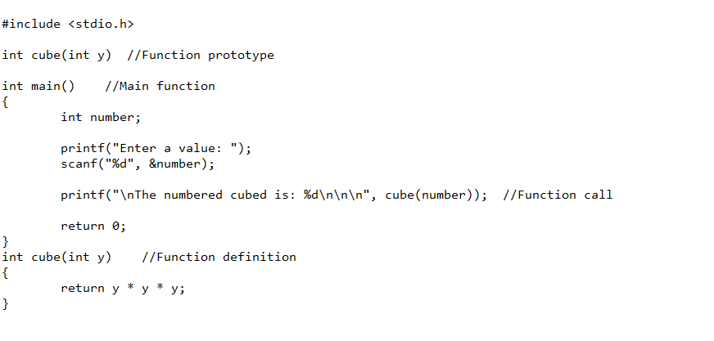
Submission Instructions
Upload a Microsoft Word Document with your answers to the questions in Part 1 and your written explanation of the error(s) and revised code for Part 2. Use this naming convention to name your Word Document:
LastName_Unit2_Assignment1.docx

